APP NAME |  |  |  | PRICE
ALL-IN-ONE
Epocrates + |  |  |  | $174.99
PHARMACEUTICAL GUIDE
Monthly Prescribing Reference (MPR) |  |  |  | FREE
Micromedex | 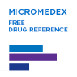 |  |  | FREE
GoodRx |  |  |  | FREE
PillTalk |  |  |  | FREE
ANTIBIOTICS GUIDE
CDC Antibiotic Guidelines |  |  |  | FREE
The Sanford Guide |  |  |  | $29.99
Johns Hopkins ABX Guide |  |  |  | $29.99
PREVENTION/SCREENING
ePSS AHRQ |  |  |  | FREE
DIFFERENTIAL DIAGNOSIS
Diagnosaurus |  |  |  | $1.99
DDx Pocket |  |  |  | $9.99
IMMUNIZATIONS
CDC Vaccine Schedule |  |  |  | FREE
Shots Immunization |  |  |  | $3.99
LAB VALUES
Smart Medical Lab Values |  |  |  | FREE
3-in-1 Lab Values |  |  |  | $2.99
Pocket Lab Values | 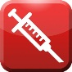 |  |  | $2.99
CALCULATORS
MedCalc (Pro) |  |  |  | FREE  ($4.99)
Calculate by QxMD |  |  |  | FREE
Mediquations |  |  |  | $4.99
MediMath |  |  |  | $4.99
APP NAME |  |  |  | PRICE
SHELF/USMLE REVIEW QUESTIONS
AFP By Topic |  |  |  | FREE
ABFM Exam Prep |  |  |  | FREE
Case Files by McGraw-Hill |  |  |  | FREE  ($29.99)
USMLE 2 Stanford Review |  |  |  | $4.99
PHYSICAL EXAM
Pocket PEx | 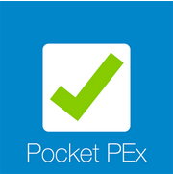 |  |  | FREE
Physical Exam Essentials |  |  |  | $2.99
iOrtho+ |  |  |  | FREE
EyeMD |  |  |  | FREE
MEDICAL NEWS
MedScape |  |  |  | FREE
NEJM This Week |  |  |  | FREE
MedPage Today |  |  |  | FREE
Read by QxMD |  |  |  | FREE
Clinical Advisor |  |  |  | FREE
PSYCHIATRY
Mental Illness | 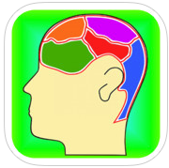 |  |  | $2.99
Psychiatry Guidelines |  |  |  | $2.99
Psych Drugs |  |  |  | FREE
OB/GYN
Perfect OB Wheel |  |  |  | $1.99
OB Wheel Pro |  |  |  | $2.85
ACOG |  |  |  | FREE
ASCCP Mobile |  |  |  | $9.99

APP NAME |  |  |  | PRICE
LANGUAGE TRANSLATION
Medical Spanish by Mavro |  |  |  | FREE
MediBabble |  |  |  | FREE
ABBREVIATIONS/EPONYMS
ABB Store (Lite) |  |  |  | $1.99  (FREE)
Eponyms |  |  |  | FREE
MEDICAL DICTIONARIES
Medictionary | 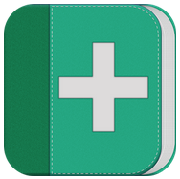 |  |  | FREE
Oxford Medical Dictionary |  |  |  | $9.99
Dorland’s Medical Dictionary | 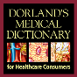 |  |  | $19.99
Stedman’s Medical Dictionary | 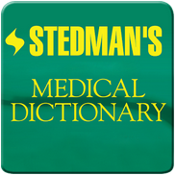 |  |  | $54.99
POINT-OF-CARE REFERENCE
Up To Date |  |  |  | SUBSCRIPTION
Essential Evidence Plus |  |  |  | FREE THROUGH NEOMED
VisualDx |  |  |  | $7.99/  month
Cancer.net |  |  |  | FREE
QUICK AT-A-GLANCE APPS
Fig. 1 |  |  |  | FREE

Roger Musa, M.D.

